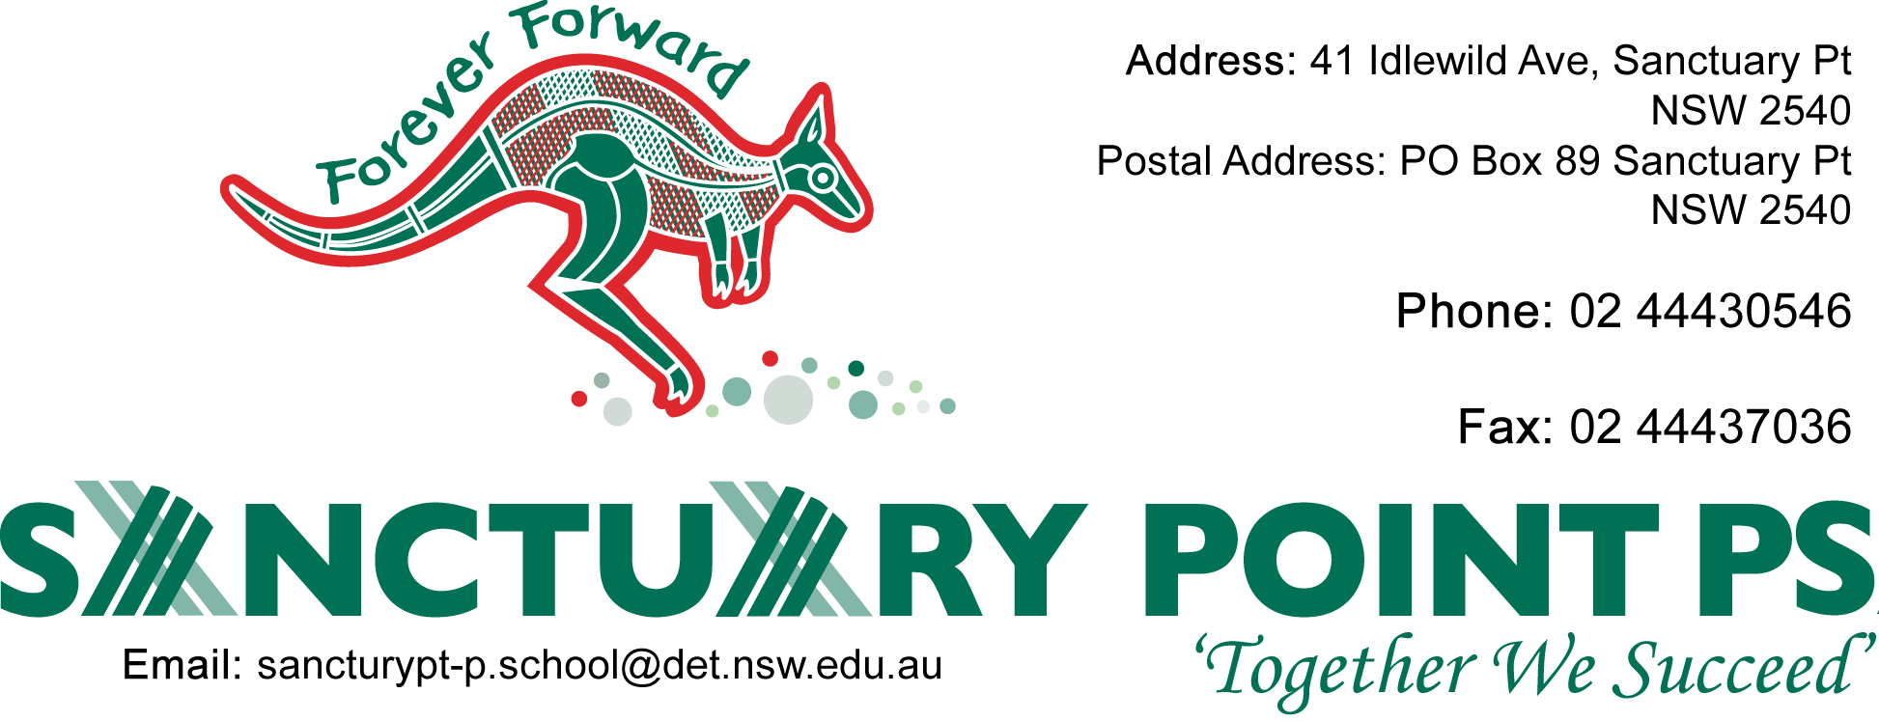
Dear Parents April 2015 The students in Kinder Banggaada will be using their own devices – ipod, ipad or android tablets, everyday at school.
I have attached a list of apps that we will be using in class. They are all free. Could you please download these apps onto your child’s device at home?
ANDROID APPS
- Drony
- Eggy 100
- Value Memory
- Phonics Reader
- Fridge Magnets
- Puzzle 4 Kids
- Kids Alphabet Game
- Kids phonics 1
- Trace the Alphabet
- Kids Math Kinder
- Join the Dots
- Learn Maths
- Safari 123
- Game Kids 2
- ABC Jungle
- Kindergarten Fun
- Kids Connect the Dots
- Kids Learn to Read
Mr Ward Mrs Wilkinson
Dear Parents April 2015 The students in Kinder Banggaada will be using their own devices – ipod, ipad or android tablets, everyday at school.
I have attached a list of apps that we will be using in class. They are all free. Could you please download these apps onto your child’s device at home?
IPAD APPS
- abc Reading Magic 1
- abc Spelling Magic 1
- abc Magic 2
- abc Magic 4
- abc Magic 5
- abc Magic 6
- Eggy 100
- Count and Match
- Number Magic 2
- Count the Fish
- Kids Counting
- Feed the Monkey
- Colour Number
- 10 Frame Fill
- Counting Madness

Mr Ward Mrs Wilkinson

